**Chapter 2**

**Limits**

**2.4 Continuity**

**Section Exercises**

**For the following exercises, determine the point(s), if any, at which each function is discontinuous. Classify any discontinuity as jump, removable, infinite, or other.**

131. 

Answer: The function is defined for all *x* in the interval .

133. 

Answer: Removable discontinuity at ; infinite discontinuity at 

135. 

Answer: Infinite discontinuity at 

137. 

Answer: Infinite discontinuities at , for 

**For the following exercises, decide if the function continuous at the given point. If it is discontinuous, what type of discontinuity is it?**

139.  at 

Answer: No. It is a removable discontinuity.

141. , at 

Answer: Yes. It is continuous.

143. , at 

Answer: Yes. It is continuous.

**In the following exercises, find the value(s) of *k* that makes each function continuous over the given interval.**

145. 

Answer: 

147. 

Answer: 

149. 

Answer: 

**In the following exercises, use the Intermediate Value Theorem (IVT).**

151. A particle moving along a line has at each time *t* a position function , which is continuous. Assume  and . Another particle moves such that its position is given by . Explain why there must be a value *c* for  such that .

Answer: Since both *s* and  are continuous everywhere, then  is continuous everywhere and, in particular, it is continuous over the closed interval . Also,  and . Therefore, by the IVT, there is a value  such that .

153. Apply the IVT to determine whether  has a solution in one of the intervals  or . Briefly explain your response for each interval.

Answer: The function  is continuous over the interval  and has opposite signs at the endpoints.

155. Let .

1. Sketch the graph of *f*.
2. Is it possible to find a value *k* such that, which makescontinuous for all real numbers? Briefly explain.

Answer: a.

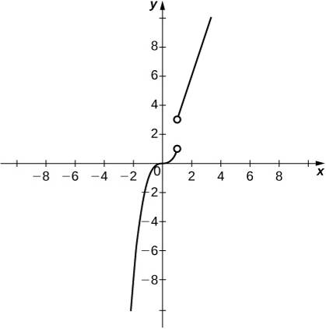;

b. It is not possible to redefine  since the discontinuity is a jump discontinuity.

157. Sketch the graph of the function  with properties i. through vii.

1. The domain of *f* is .
2. *f* has an infinite discontinuity at .
3. 
4. 
5. 
6. *f* is left continuous but not right continuous at .
7.  and 

Answer: Answers may vary; see the following example:

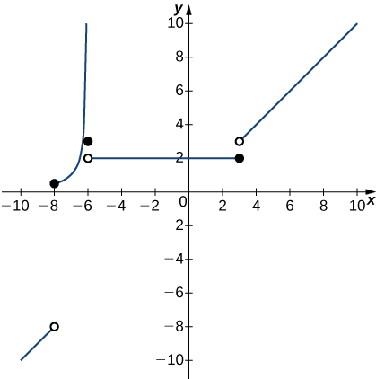

**In the following exercises, suppose  is defined for all *x*. For each description, sketch a graph with the indicated property.**

159. Discontinuous at  with  and 

Answer: Answers may vary; see the following example:

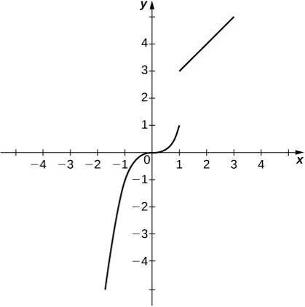

**Determine whether each of the given statements is true. Justify your response with an explanation or counterexample.**

161.  is continuous everywhere.

Answer: False. It is continuous over .

163. If a function is not continuous at a point, then it is not defined at that point.

Answer: False. Consider.

165. If  is continuous such that  and  have opposite signs, then  has exactly one solution in .

Answer: False. Consider  on .

167. If is continuous everywhere and , then there is no root of in the interval .

Answer: False. The IVT does *not* work in reverse! Consider over the interval

**[T] The following problems consider the scalar form of Coulomb’s law, which describes the electrostatic force between two point charges, such as electrons. It is given by the equation, where  is Coulomb’s constant,  are the magnitudes of the charges of the two particles, and *r* is the distance between the two particles.**

169. Instead of making the force 0 at *R*, instead we let the force be 10–20 for . Assume two protons, which have a magnitude of charge , and the Coulomb constant. Is there a value *R* that can make this system continuous? If so, find it.

Answer: 

**Recall the discussion on spacecraft from the chapter opener. The following problems consider a rocket launch from Earth’s surface. The force of gravity on the rocket is given by  where *m* is the mass of the rocket, *d* is the distance of the rocket from the center of Earth, and *k* is a constant.**

171. **[T]** After a certain distance *D* has passed, the gravitational effect of Earth becomes quite negligible, so we can approximate the force function by. Find the necessary condition *D* such that the force function remains continuous.

Answer: 

**Prove the following functions are continuous everywhere**

173. 

Answer: For all values of ,  is defined,  exists, and . Therefore,  is continuous everywhere.

175. Where iscontinuous?

Answer: Nowhere

This file is copyright 2016, Rice University. All Rights Reserved.